A project Report On

**Vote Mania**

Submitted in partial fulfillment of the requirement for the award of the degree

MASTER OF COMPUTER APPLICATIONS (INTEGRATED)

From

Gujarat Technological University



Academic Year 2017– 18

**Moin Kureshi : 165220686021**

**Shahil Khambhayta : 165220686020**

|  |
| --- |
| **Internal Guide** |
| Prof. Sunil Bajeja |

Marwadi Education Foundation’s Group of Institutions

(MEFGI)

Rajkot-Morbi Road, At & PO : Gauridad, Rajkot 360 003. Gujarat. India.



**Faculty of Computer Applications (FCA)**



**This is to certify that the project work entitled**

**Vote Mania**

**Submitted in partial fulfillment of the requirement for**

**the award of the degree of**

**Master of Computer Applications (Integrated)**

**of the**

**Gujarat Technological University**

**Is a result of the bonafide work carried out by**

**Moin Kureshi : 165220606021**

**Shahil Khambhayta : 165220686020**

**During the academic year 2017 – 2018**

|  |  |  |  |  |
| --- | --- | --- | --- | --- |
| **Faculty Guide** |  | **HOD** |  | **Dean** |

**External Viva**

|  |  |  |
| --- | --- | --- |
| **Name of the Examiners** |  | **Signature with Date** |

**DECLARATION**

We hereby declare that this project work entitled **Vote Mania** is a record done by us.

We also declare that the matter embodied in this project is genuine work done by us and has not been submitted whether to this University or to any other University / Institute for the fulfillment of the requirement of any course of study.

Place: **_____________________**

Date: **_____________________**

**Moin Kureshi (165220686021) Signature: _________**

**Shahil Khambhayta (165220686020) Signature: _________**

**ACKNOWLEDGEMENT**

We acknowledge with gratitude the motivation and support we received from the Management of our college. Doing such a project on Timetable Generator would not be possible without invaluable-Inputs and inspiration from many of our fellow creative intellectuals. We are indeed grateful to Prof. **Divyakant Meva** for his guidance and encouragement we received. We are also thankful to our faculties of **MCA**  department for guiding us.

In addition, we thank all our seniors, well-wishers, family members and friends for their invaluable support.

**Moin Kureshi (165220686021) Signature: _________**

**Shahil Khambhayta (165220686020) Signature: _________**

**CONTENTS**

|  |  |  |
| --- | --- | --- |
| **Chapters** | **Particulars** | **Page No.** |
| **1** | **SYNOPSIS** | 9 |
| **2**  2.1  2.2 | **PREAMBLE**  Project Description  Modules and Description | 10  11/12 |
| **3**  3.1  3.2 | **TECHNICAL DESCRIPTION**  Hardware Requirement  Software Requirement | 13 |
| **4**  4.1  4.2 | **SYSTEM DESIGN AND DEVELOPMENT**  File Structure with Description  Flow Structure | 14  15 |
| **5** | **SYSTEM TESTING** |  |
| **6** | **SCREEN SHOTS** |  |
| **7** | **SOURCE CODE** |  |
| **8** | **CONCLUSION** |  |
| **9**  9.1  9.2 | **BIBLIOGRAPHY**  Online References  Offline References |  |

**FIGURE INDEX**

|  |  |  |  |
| --- | --- | --- | --- |
| **Sr. No.** | **Figure No.** | **Particulars** | **Page No.** |
| 1 | 1 | Context Diagram | 15 |
| 2 | 2 | 0-Level Diagram | 15 |
| 3 | 3 | Use Case Diagram | 16 |
| 4 | 4 | Class Diagram | 16 |
| 5 | 5 | Sequence Diagram | 17 |
| 6 | 6 | Activity Diagram(Result) | 17 |
| 7 | 7 | Activity Diagram(Create Poll) | 18 |
| 8 | 8 | Activity Diagram(Vote Poll) | 19 |
| 9 | 9 | ER Diagram | 20 |

**TABLE INDEX**

|  |  |  |  |
| --- | --- | --- | --- |
| **Sr. No.** | **Table No.** | **Particulars** | **Page No.** |
| 1 | 3.1 | Hardware Requirement | 13 |
| 2 | 3.2 | Software Requirement | 13 |

**1. SYNOPSYS**

Vote Mania is a project about user hosting a poll and he/she can include candidates as he/she wants and create a new poll for the other user. The user can vote to their choice of candidates as mentioned in the poll but to create a poll and to vote one must login/sign up.the result will be represented in the form of the graphs.

**2.PREAMBLE**

**2.1. Project Details:**

“Vote Mania” is an website in which the user can create a poll with certain candidates as an option to vote for. The users can vote to certain poll candidates as they like after voting the results will be shown to voter in the form of graphs. The hosted poll can be of any subject like sports, politics, entertainment.

But to host a poll and vote for other poll the user must have to sign (up if you don’t have your account) or login. The created poll will have limited amount of time assigned to it after that other users cant vote and final result will be shown.

**2.2 Modules**

-Host Poll

-Vote

-Search Poll

-Notification

-Profile

**2.3 Module Description**

-Host poll

user can host a new poll. User hosting poll needs to enter candidates (min 2) and closing time of poll. user can add tags so voter can search poll by keyword.

-Vote

voter after login can vote in their desired poll. voter can select voter can select one option or multiple options based on poll type.

-Search poll

if voter wants to search poll on particular topic he/she can find it by search that keyword. poll will be compared by voter's keyword and poll tags and if matches it will be shown.

-Notification

when poll ends voter get notification about result of poll they have voted.

-Profile

User can see or update their details in profile. And can see poll they have created.

**3.TECHNICAL DESCRIPTION**

**3.1 Hardware Requirement**

**3.2 Software Requirement**

**4.System Design and Development**

**4.1 File Structure And Description**

**\*Data Dictionary**

**User Table:-**

|  |  |  |  |  |
| --- | --- | --- | --- | --- |
| Field Name | Type | Null | Default | Constraints |
| Uid | Int(5) | No | - | Primary Key |
| Password | Varchar(15) | No | - | - |
| Uname | Varchar(20) | No | - | - |
| Gender | Varchar(11) | No | - | - |
| City | Varchar(20) | No | - | - |

**Poll Table:-**

|  |  |  |  |  |
| --- | --- | --- | --- | --- |
| Field Name | Type | Null | Default | Constraints |
| Pid | Int(5) | No | - | Primary Key |
| Uid | Int(5) | No | - | Foreign Key |
| Question | Varchar(50) | No | - | - |
| Deadline | DateTime | No | - | - |
| Tags | Varchar(20) | No | - | - |

**Options Table:-**

|  |  |  |  |  |
| --- | --- | --- | --- | --- |
| Field Name | Type | Null | Default | Constraints |
| Pid | Int(5) | No | -- | Foreign Key |
| Text | Varchar(20) | No | -- | - |
| Image | Long Blob | Yes | -- | - |
| Total | Int(5) | Yes | -- | - |

|  |  |  |  |  |
| --- | --- | --- | --- | --- |
| Field Name | Type | Null | Default | Constraints |
| Nid | Int(5) | No | - | Primary Key |
| Uid | Int(5) | No | - | Foreign Key |
| Message | Varchar(20) | No | - | - |
| Seen | Boolean | No | False | - |

**Notifiation Table:-**

**4.2 Flow Structure**

**-Context Diagram**

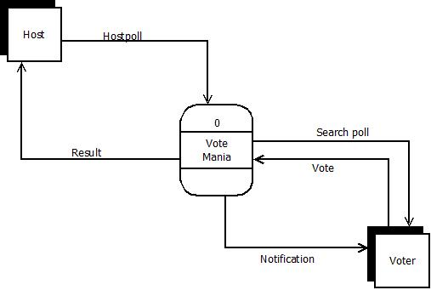

**-0 Level Diagram**

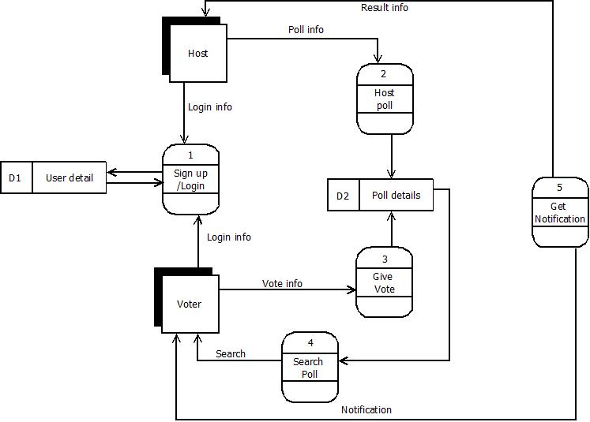

**-Use Case Diagram**

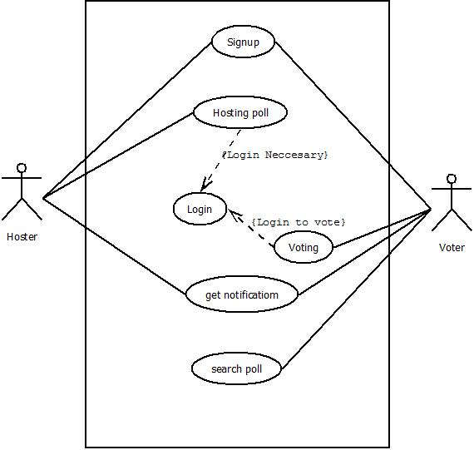

**-Class Diagram**

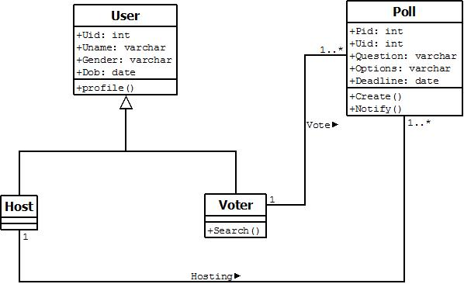

**-Sequence Diagram**

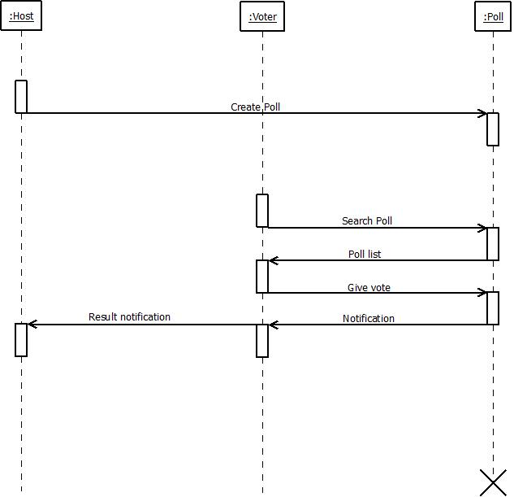

**-Activity Diagram(Result)**

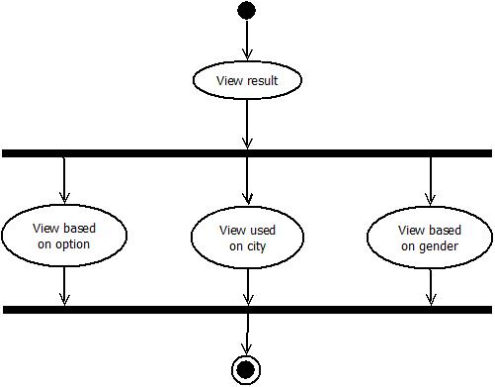

**-Activity Diagram(Create Poll)**

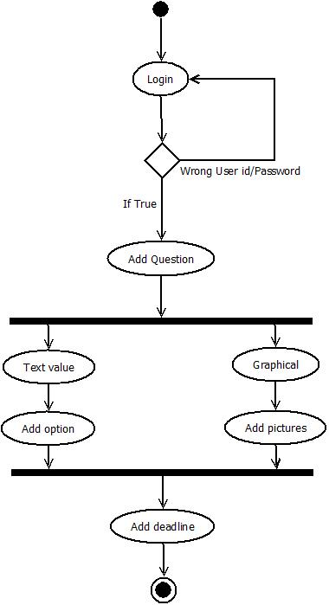

**-Activity Diagram(Vote Poll)**

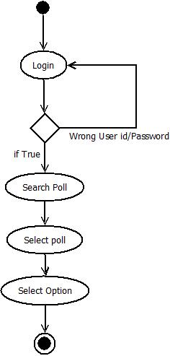

**-ER Diagram**

